Government of India
***

Shri Narendra Modi laid the foundation stone of Petrochemical Complex at BPCL’s Bina Refinery
September 14, 2023

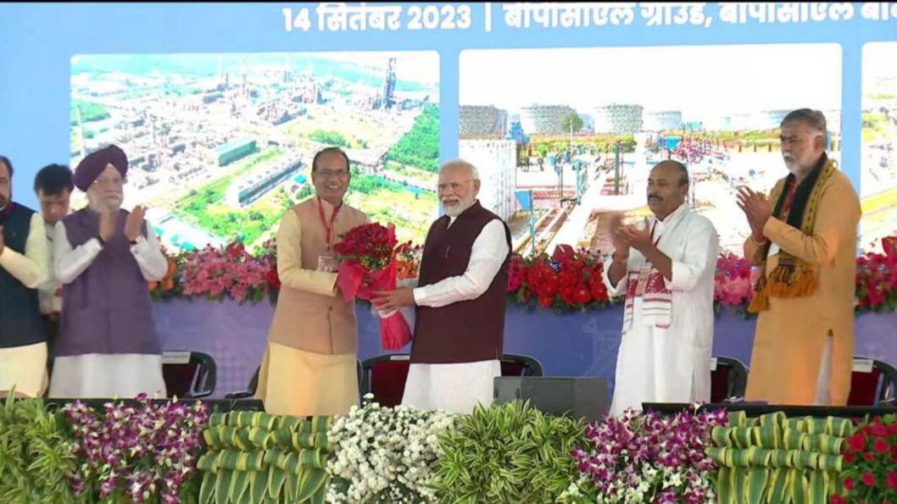
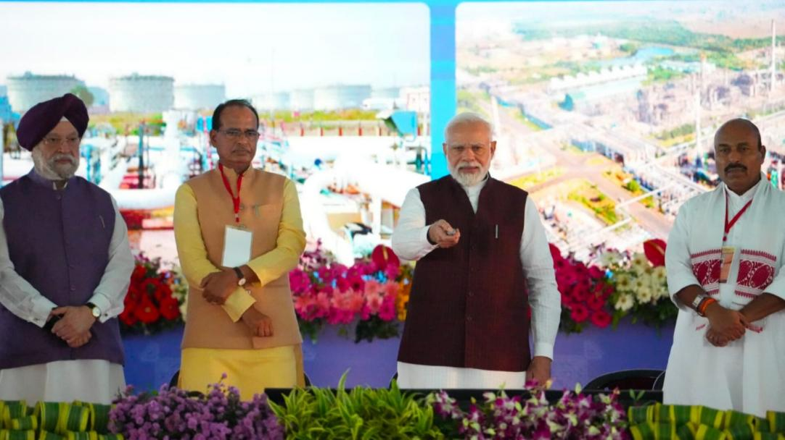

Hon'ble Prime Minister Shri Narendra Modi laid the foundation stone of Petrochemical Complex at BPCL’s Bina Refinery in presence of Hon’ble Chief Minister, MP, Shri Shivraj Singh Chouhan, Hon'ble Minister of Petroleum & Natural Gas and Minister of Housing & Urban Affairs Shri Hardeep Singh Puri, and dignitaries from Government of India, MP Government.
BPCL is investing Rs. 49,000 Crores in Bina Refinery to set up a 2.2 MMTPA capacity Petrochemical Plants, as well as, expanding the refinery capacity to 11 MMTPA.
The project, which will be completed in 5 years, will boost investment from downstream industries which use these niche petrochemicals, like paints, plastics, automotive parts, etc., which will generate more than 1 lakh direct and in direct employment.
India will save forex of Rs. 20,000 Crore annually through import substitution, once this project gets commissioned.
#VistarSeVikas #BinaRefinery #BinaRefineryExpansion #BulandBundelkhand

