Urja Sangam
27 Mar 2015 Oil Industry Update
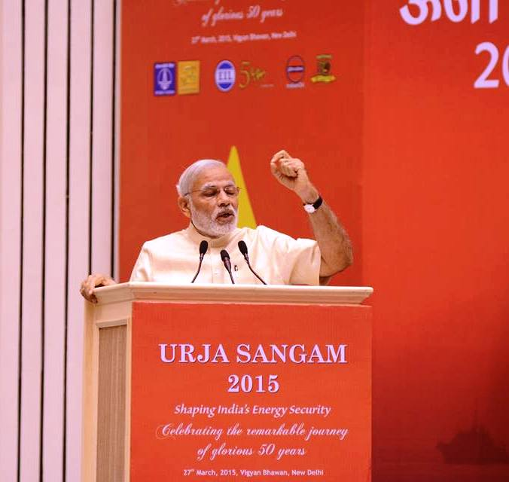
Hon'ble PM inaugurates Urja Sangam 2015

Hon'ble PM Shri Narendra Modi ji inaugurated Urja Sangam 2015 organised by Petroleum Ministry at Vigyan Bhawan, New Delhi, on 27 March 2015. He stressed on Energy self sufficiency in India. In today's era Energy security is both a need & necessity and PM exhorted all to be focused on upliftment of the common & poor man of India. He also congratulated Petroleum Minister & the Ministry for successful initiatives & bringing reforms in last 10 months.

The Prime Minister called for enhancing domestic production to reduce the energy import burden of the country by at least 10 percent, till 2022 – the occasion of the platinum jubilee of India’s independence.

The Prime Minister highlighted various achievements of the Union Government, and reforms initiated in the energy sector over the last ten months. He said these reforms were motivated by the quest for greater energy security, which is both a necessity and responsibility. He said transfer of LPG subsidy directly into bank accounts through the world’s largest cash subsidy transfer programme in the world – PAHAL – had resulted in elimination of leakages, and curbing corruption. He also mentioned deregulation of diesel prices, ethanol blended petrol to help sugarcane farmers, promotion of bio-diesel, and extension of the gas grid in eastern India, as some of the other major initiatives of the Government. The Prime Minister said the Union Government aims to extend piped natural gas (PNG) to one crore houses over the next five years.

The Prime Minister called upon Indian energy companies to become multinational; work towards India-Middle East, India-Central Asia, and India-South Asia energy corridors; and establish gas positions in North America and Africa.

Union Ministers Shri Ravi Shankar Prasad, Shri Dharmendra Pradhan, Smt. Nirmala Sitharaman, and Shri Nasrul Hamid – State Minister for Power, Energy and Mineral Resources of Bangladesh, were present on the occasion.

Read More: http://www.narendramodi.in/pm-at-urja-sangam-2015/

